***The World Islamic Science and Education University***

جامعة العلوم الاسلامية العالمية

Faculty of Information Technology

كلية تكنولوجيا المعلومات



GRADUATION PROJECT

**Title**:

*E-practical training*

**Students**:

|  |  |
| --- | --- |
| Mohammad Abdallah | 3180605071 |
| Ali Alqawasmeh | 3180601046 |

**Supervisor**: Dr. Hasan Abualese

Semester II

2021/2022

**Acknowledgments**

A very hart warming gratitude to all of those who helped us reach this day, without them we would not be here.

**Abstract**

The idea of ​​the project is through the problem of routine procedures in submitting the application, where the student must go to more than one place to be able to apply, and also some students face a problem in finding a training company for them, as problems may occur because of that in terms of that. The solution lies in creating a platform in the student portal to conduct practical exercises, as it allows you to choose the company and the type of training through several options and help students who do not know the type of training they want and allow them to apply electronically through the company’s website and direct communication between the student and the company. It also allows companies to provide University training offers. We implemented our project using Agile methodology and Kanban board method in this project. This project allows the student to register electronically and be able to communicate with the company and apply directly to them. It also allows for a contract between the university and technical companies.

Table of Contents

Chapter 1: Introduction………………………………………………………………………………………………….6

1.1. Overview……………………………………………………………………………………………………………6

1.2. Problem statement…………………………………………………………………………………………………..6

1.3. Project objectives……………………………………………………………………………………………...……6

1.4. Research strategy……………………………………………………………………………………………..…….6

1.5. Gantt chart…………………………………………………………………………………………………………8

1.6. Project outline…………………………………………………………………………………………………..…9

Chapter 2: Literature review …………………………………………………………………………………………..10

2.1. Overview…………………………………………………………………………………………………………..10

2.2. Related work……………………………………………………………………………………………………....10/11

**Chapter 3: Methodology…………………………………………………………………………………………….….11**

3.1. Overview…………………………………………………………………………………………………………………………………………………………..11

3.2. Feasibility study……………………………………………………………………………………………...……11

3.3. Requirements and tools……………………………………………………………………………………………12

3.3.1. Functional requirements……………………………………………………………………………..…….12

3.3.2. Non-Functional requirements……………………………………………………………………………..13

3.3.3. Tools used…………………………………………………………………………………………………13

3.4. Methodology process……………………………………………………………………………………...………14

**Chapter 4: Design Models………………………………………………………………………………………...…….16**

4.1. Overview…………………………………………………………………………………………………...………16

4.2. Context diagram…………………………………………………………………………………………..………..16

4.3. Use case diagram………………………………………………………………………………………..………….17

4.4. Dataflow diagram……………………………………………………………………………………..……………18

4.4. Entity-relationship diagram…………………………………………………………………………...……………19

**Chapter 5: Experiments and results……………………………………………………………………..……………..20**

5.1. Overview……………………………………………………………………………………………...……………20

5.2. Testing methodologies………………………………………………………………………………...……………20

5.2.1. Unit Testing……………………………………………………………………………………..…………20

5.2.2. Integration Testing……………………………………………………………………………...………….35

5.2.3. System Testing…………………………………………………………………………………..…………38

**Chapter 6: Conclusion…………………………………………………………………………………………………...39**

6.1. Conclusion………………………………………………………………………………………………………….39

6.2. Future work…………………………………………………………………………………………………………39

References…………………………………………………………………………………………………………………40

Appendix…………………………………………………………………………………………………………………..41

**List of tables**

Table 1: Gant chart………………………………………………………………………………………………………8

Table 2: Related work comparison………………………………………………………………………………............11

**List of figures**

Figure 1: Agile methodology……………………………………………………………………………………………...7

Figure 2: Kanban board…………………………………………………………………………………………….…….15

Figure 3: Context diagram………………………………………………………………………………………….…….16

Figure 4: Use case diagram………………………………………………………………………………….……..…..…17

Figure 5: Dataflow diagram………………………………………………………………………………….…………..18

Figure 6: Er diagram…………………………………………………………………………………………..…...……..19

Figure 7: Test case …………………………………………………………………………………………………..…35

Figure 8: Bug report…………………………………………………………………………………………………..…36

Abbreviations:

1. E: electronic.
2. GUI: Graphical user interface.
3. WISE: world Islamic sciences and education university.
4. HU: Hashemite University

**Chapter 1**

**“Introduction”**

1.1 Introduction.

This project deals with the idea of a gradual transition to electronic transactions, as we presented the idea of providing practical training to companies electronically, as well as the idea of cooperation between companies and the university. The university is the scope of work where the project will be implemented, and there are no projects in Jordanian universities similar to the faculties of Information Technology.

1.2 Problems statement.

The problem of routine procedures in submitting the application, where the student must go to more than one place to be able to apply, and also some students face a problem in finding a training company for them, as problems may occur because of this in terms of delay in training and also the problem of the paper and routine procedures, which must be transferred to an electronic form for the development of the university.

Reference:

Mr. Osama Ghunaimat Director of the Dean's Office at the College of Information Technology

1.3 Project objectives.

1- Creating an electronic platform in the student portal that allows him to apply for practical training electronically.

2- Helping the student to find a suitable company for training by providing several suggestions.

3- Contributing to the development of the university by converting paper-based procedures to electronic ones.

4- Contribute to the development of relations between technology companies and the university through contracts between them.

1.4 Research strategy.

We’ve decided to use the agile methodology as well as using the Kanban board method in this project due to these reasons:

1. Agile works well with shorter turnaround times and tight deadlines, and the duration given for this project is fairly short.
2. Unclear requirements and the possibility of a change, agile methodologies work well when the project has few initial requirements and doesn’t need to meet strict regulations.
3. The possibility of working on some specifications only without the need to complete all specifications.
4. A Kanban board is an agile project management tool designed to help visualize work, limit work-in-progress, and maximize efficiency (or flow).



*Figure 1: Agile methodology*

1.5 Gantt chart.

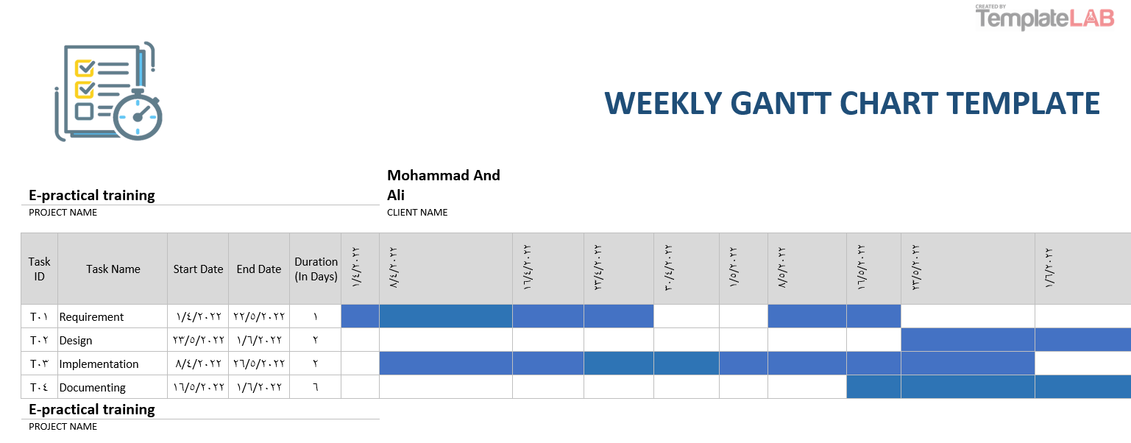

*Table 1: Gant chart*

1.6 Project outline.

Chapter 1: Introduction.

This chapter explains the project’s purpose by stating the problems that need to be solved, the project’s objectives, the research strategy, the Gantt chart, and this project outline.

Chapter 2: A literature review.

In this chapter, we will learn about some examples and practical applications of the project from other universities and provide a theoretical description of the project.

Chapter 3: Methodology.

This chapter goes through the feasibility study for this project and the methodologies used, the functional and non-functional requirements, as well as the tools used in developing this project.

Chapter 4: Design Models.

This chapter demonstrates how the system works by showing a set of diagrams.

Chapter 5: Experiments and results.

This chapter goes through the processes that happened during the implementation and testing of the project.

Chapter 6: Conclusion.

A quick summary of the project and the plans for future works.

**Chapter 2**

**“Literature review”**

2.1 Overview.

In this chapter, we will be going through some related works in this field and discussing their limitations and what we think this project will provide that other works don’t have.

2.2 Related Work.

The following are some of the regulations in force in some Jordanian universities in this field with mentioning the name of the university:

* The Hashemite University

Hashemite University implements its electronic training system, where the student in the College of Engineering can apply electronically, and then the university communicates between the student and the company.

-We compared the two universities through a few key things:

\***Electronic submission**: Owning an electronic registration system for practical training.

\***Company selection**: The ability to choose a company from a range of available options.

\***Student contact with the company**: The ability to communicate directly between the student and the company.

\***Ease of use**: Ease of use by the student

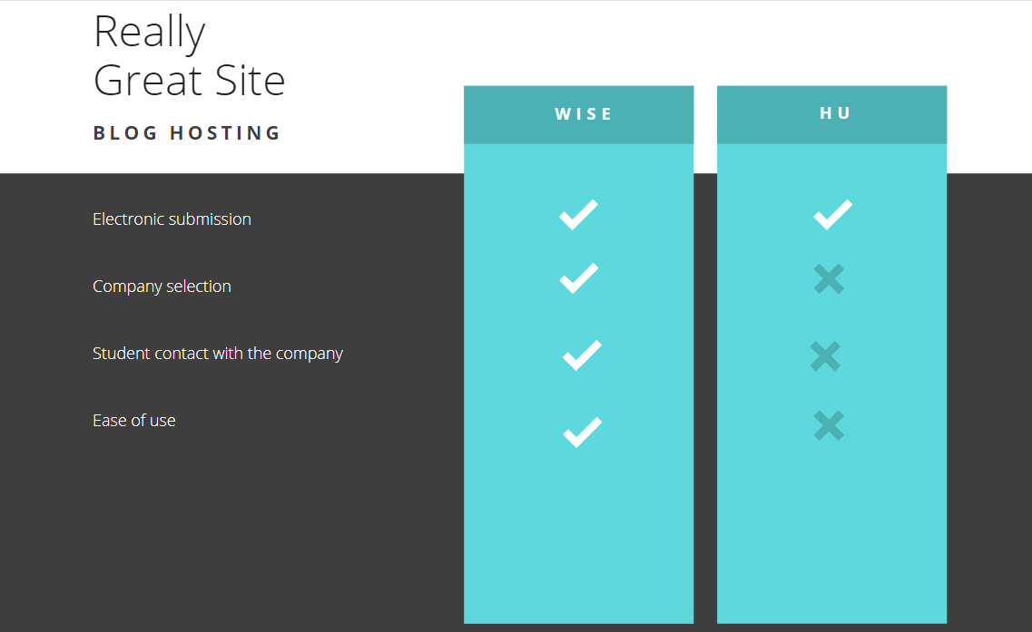

*Table 2: Related work comparison*

2.2.1 Project application scenario.

First, companies submit training offers to the university, where the university accepts or rejects the offer then, the student chooses the company and submits to it through the company’s website. The application is stored in the company’s database. The company responds to the student with approval or rejection via e-mail, where he uploads the admission file to the university via the website.

**Chapter 3**

**“Methodology”**

3.1 Overview.

In this chapter, we’ll go through the methodologies and tools used to develop this project.

From the feasibility study followed by the functional and non-functional requirements and the tools used, to the data collecting methods used.

* 1. Feasibility study.

3.2.1 Technical feasibility.

Cost-effectiveness represents the tools and techniques used.

|  |  |
| --- | --- |
| Item | Estimated cost |
| The devices used | 150 |
| Tools | 50 |
| Other | 50 |
| Total | 250 |

3.2.2 Operational feasibility.

It represents the feasibility of the things we need to run the project

|  |  |
| --- | --- |
| Item | Estimated cost |
| Servers | 100 |
| Database | 50 |
| Other | 50 |
| Total | 200 |

3.3 Requirements.

In this section, the requirements will be divided into functional and non-functional requirements.

3.3.1 Functional requirements.

The admin must have access to the following functions:

|  |  |  |
| --- | --- | --- |
| ID | ID name | Description |
| 1 | Log in | Admin can log in to his page using his username and password |
| 2 | Approval or rejection of companies | The Administrator receives requests for training offers from companies, where he either approves or rejects them |
| 3 | modifying or deleting a company | The admin can edit or delete companies through his page, where if the contract between the university and the company ends, he deletes it |
| 4 | Receiving requests from students | The Administrator receives the approval requests that the student sends through the website and delivers them to the university |
| 5 | Show student assessments | The admin can see the evaluations of each student as the company evaluates each student it has |
| 6 | Sign out | Sign out of his page |

The student should have access to these functions:

|  |  |  |
| --- | --- | --- |
| ID | ID name | Description |
| 1 | Log in | Students can log in to his page using their username and password |
| 2 | Choose the company | The student can choose a company from a group of companies available for training and also choose the type of training he wants |
| 3 | Submit a training request | The student submits a training request to the company through its website, where he fills in some important information |
| 4 | Send an approval file | The student sends the admission file that was sent to him from the company to the university through the website |
| 5 | Sign out | Sign out of his page |

The company should have access to these functions:

|  |  |  |
| --- | --- | --- |
| ID | ID name | Description |
| 1 | Submit a training offer | The company submits a training offer to the university, where it fills in the data required for submission |
| 2 | Show additional training | The company is creating an additional introductory page for the student, which is based on placing all the important information for the student for training |
| 3 | Approval or rejection of the trainee | The company approves or rejects each student's training request by sending an email containing either approval or rejection |
| 4 | Send the training approval | After the company agrees to train the student, it sends an admission file to the student |
| 5 | Evaluate the trainee | The company evaluates each trainee during the training period and presents the evaluations to the university |

3.3.2 Non-Functional requirements.

* **Security**

Each user (student) has a user name and a private password that is stored in the university database and is protected so that no one can access it and each user (administrator) has a job number and a protected password.

The server is protected in the same way that the university website is protected.

* **User-friendly and simplicity**

Simple design interface with ease of navigation, ease of choosing the company, ease of applying, and sending the approved file to the university.

* **Ease of use**

The website is simple to use with straightforward functionality.

3.3.3 Tools used.

The tools that are used in developing this website are:

* Visual studio code (code editor)
* PHP (backend language)
* MySQL (relational database management system ‘RDBMS’)
* XAMPP (locale server)
* HTML, CSS, JavaScript (frontend formatting languages)
* GitHub (code hosting platform)
* Discord (communication tool)
* Draw.io diagram
* Bootstrap 4
* canva

3.4 Methodology process.

This project is using the agile methodology and the Kanban method for building the E-practical training system.

Advantages of Kanban:

1. It’s focused on continuous delivery.
2. Kanban is easy to understanding methodology.
3. It reduces the time cycle of the process.

This table represents the Kanban board at one point during the development of this project:

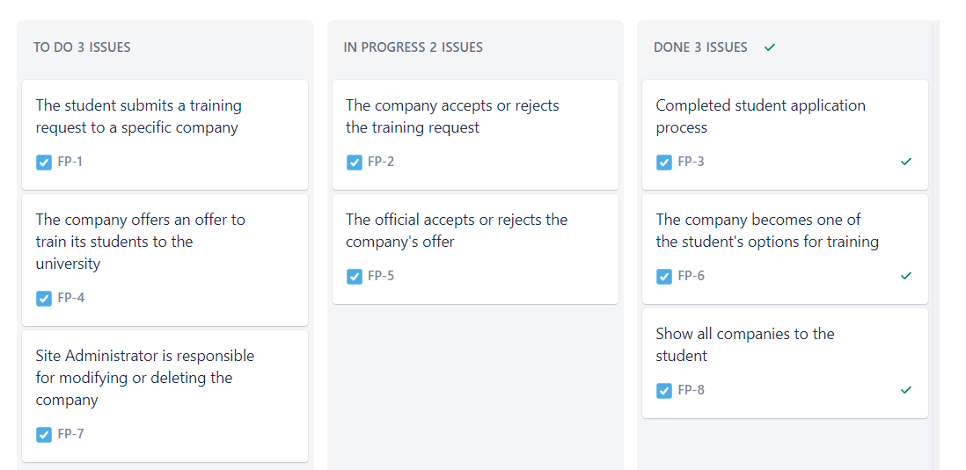

*Figure 2: Kanban board*

3.4.1 Data collection.

-Interviews:

While collecting the specifications, we used the interview technique, where we went back to the university and asked the Office of the College of Information Technology about the mechanism of doing some things during the application for practical training, and we were able to convert them into an electronic form.

**Chapter 4**

**“****Design Models”**

1. Overview.

This chapter will contain the design diagrams that represent this system, including a context diagram, use case diagram, data flow diagrams, and an ER diagram.

2. Context diagram.

This is a context-level data flow diagram (level 0) that shows the main users of the system as well as the way that they’re going to be interacting with the system.  
  
The system has 3 types of users: student, company, and admin.

And each of them interacts with the system as shown in the diagram below.

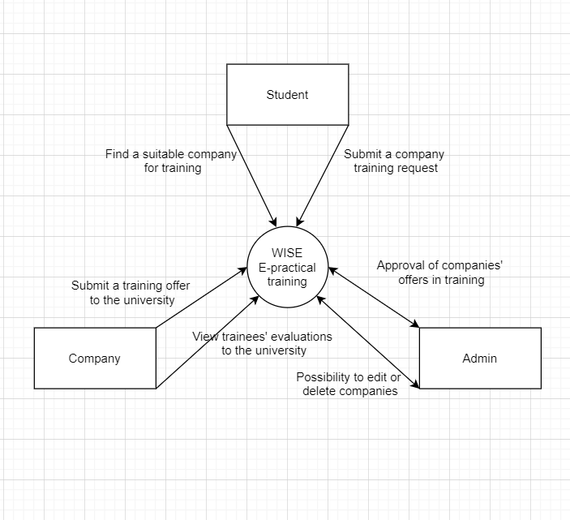

*Figure 3: Context diagram*

3. Use a case diagram.

With the use case diagram, we can identify the three types of actors and the functions (use cases) that the system must provide for these actors.

actors:

1-student

2-admin

3-company

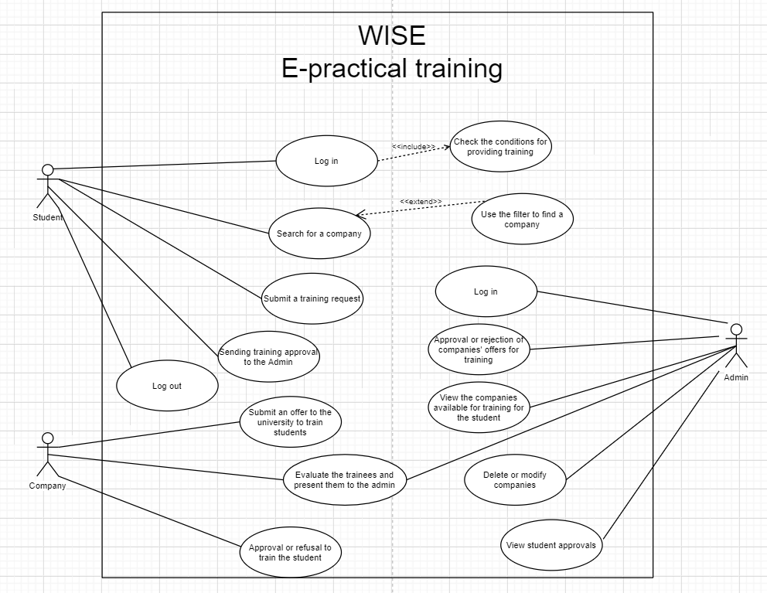

*Figure 4: Use a case diagram*

4. Dataflow diagram.

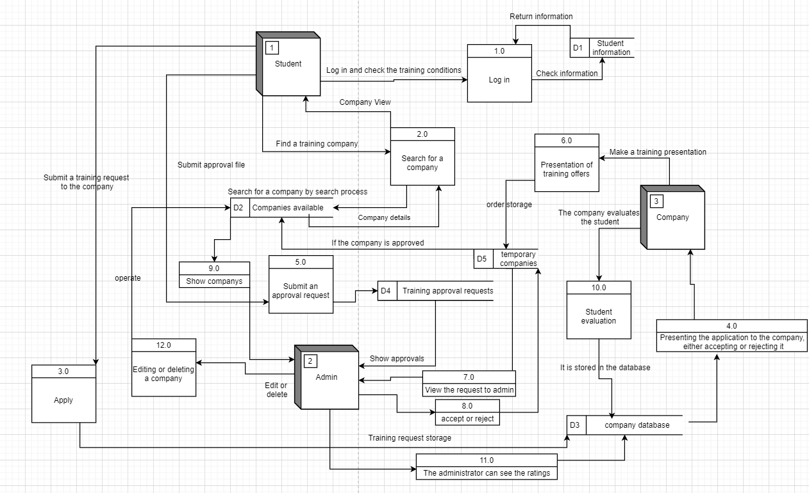

*Figure 5: Dataflow diagram*

5. Entity relationship diagram.

The ER diagram shows us the entity types in the database which are the students, companies, and the admin.

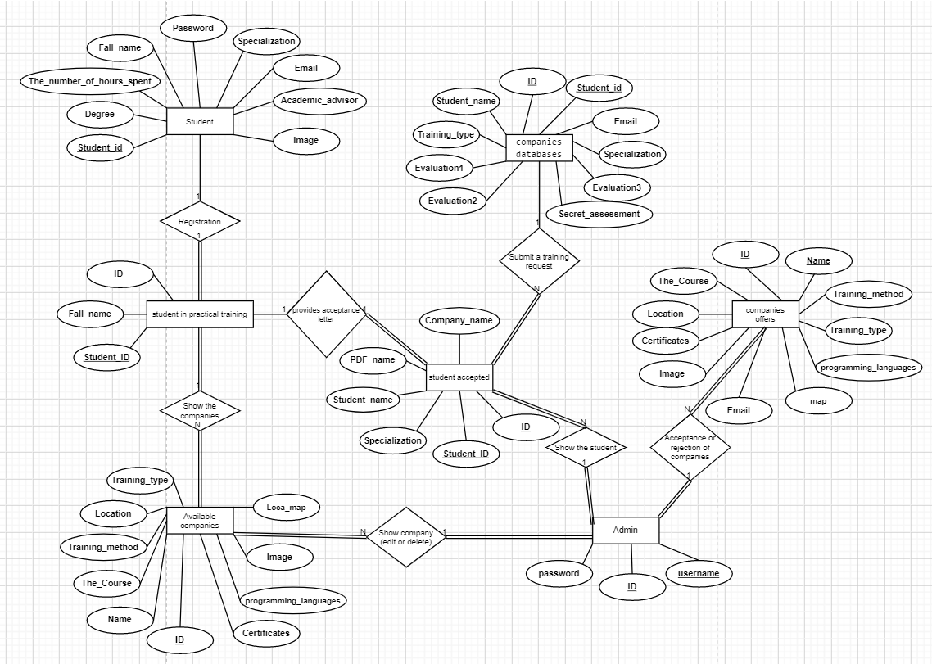

*Figure 6: Er diagram*

**Chapter 5**

**“Experiments and results”**

5.1 Overview.

In this chapter, we did some testing on the system to ensure that all functions meet the requirements, and we documented all the results and our test cases.

5.2 Testing methodologies.

5.2.1 Unit Testing.

Unit-testing checks every part of the system

|  |  |  |
| --- | --- | --- |
| Test ID | Test name | Operate |
| 1:00 | Log in | Student, admin |
| 2:00 | Submit a training offer | Company |

5.2.1.1.1 Test ID 1 for Students

|  |  |  |
| --- | --- | --- |
| Username | Password | Result |
| 🗸 | 🗸 | Valid |
| 🗸 | 🗴 | Invalid |
| 🗴 | 🗸 | Invalid |
| 🗴 | 🗴 | Invalid |

|  |  |  |  |
| --- | --- | --- | --- |
| Test-ID | Test case | Example | Output |
| 1.1 | User: correct  Pass: correct | User: 3180605071  Pass: UFUA912345 | Student page |
| 1.2 | User: correct  Pass: incorrect | User:3180605071  Pass: UFUA00000 | Error message |
| 1.3 | User: incorrect  Pass: correct | User:31806050  Pass: UFUA00000 | Error message |
| 1.4 | User: incorrect  Pass: incorrect | User:31806050  Pass: UFUA000 | Error message |

|  |  |
| --- | --- |
| Test-ID: 1.1.1 | |
| Input | |
|  |  |

|  |  |
| --- | --- |
| Test-ID: 1.1.1 | |
| Output | |
|  |  |

|  |  |
| --- | --- |
| Test-ID: 1.2.1-4 | |
| Input | |
|  |  |

|  |  |
| --- | --- |
| Test-ID: 1.2.1-4 | |
| Output | |
|  |  |

5.2.1.1.2 Test ID 1 for Admin

|  |  |  |
| --- | --- | --- |
| Username | Password | Result |
| 🗸 | 🗸 | Valid |
| 🗸 | 🗴 | Invalid |
| 🗴 | 🗸 | Invalid |
| 🗴 | 🗴 | Invalid |

|  |  |  |  |
| --- | --- | --- | --- |
| Test-ID | Test case | Example | Output |
| 1.1 | User: correct  Pass: correct | User: 0558915  Pass: admin123 | Admin page |
| 1.2 | User: correct  Pass: incorrect | User: 0558915  Pass: admin999 | Error message |
| 1.3 | User: incorrect  Pass: correct | User: 0558111  Pass: admin123 | Error message |
| 1.4 | User: incorrect  Pass: incorrect | User: 0558555  Pass: admin666 | Error message |

|  |  |
| --- | --- |
| Test-ID: 1.1.2 | |
| Input | |
|  |  |

|  |  |
| --- | --- |
| Test-ID: 1.1.2 | |
| Output | |
|  |  |

|  |  |
| --- | --- |
| Test-ID: 1.2.2-4 | |
| Input | |
|  |  |

|  |  |
| --- | --- |
| Test-ID: 1.2.2-4 | |
| Output | |
|  |  |

5.2.1.1 Test ID 2

|  |  |  |  |
| --- | --- | --- | --- |
| Test-ID | Test case | Example | Output |
| 2.1 | Correct and complete information | All information | Submit a success request |
| 2.2 | Entering the same company again | Enter the company name again | Error message |
| 2.3 | Not entering some information | Not entering the certificates provided by the company | Error message |

|  |  |
| --- | --- |
| Test-ID: 2.1 | |
| Input | |
|  |  |

|  |  |
| --- | --- |
| Test-ID: 2.1 | |
| Output | |
|  |  |

|  |  |
| --- | --- |
| Test-ID: 2.2 | |
| Input | |
|  |  |

|  |  |
| --- | --- |
| Test-ID: 2.2 | |
| Output | |
|  |  |

|  |  |
| --- | --- |
| Test-ID: 2.3 | |
| Input | |
|  |  |

|  |  |
| --- | --- |
| Test-ID: 2.3 | |
| Output | |
|  |  |

5.2.2 Integration Testing.

Here we can see one of the test cases that we implemented on the student login page to see if it works as intended with the database:

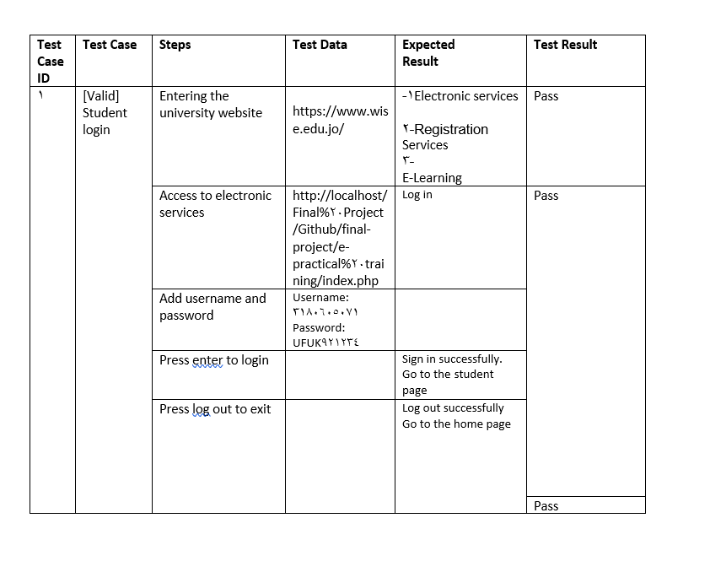

*Figure 7: A test case.*

And here we can see one of the bug reports for a bug that was discovered on the “Admin site” page:

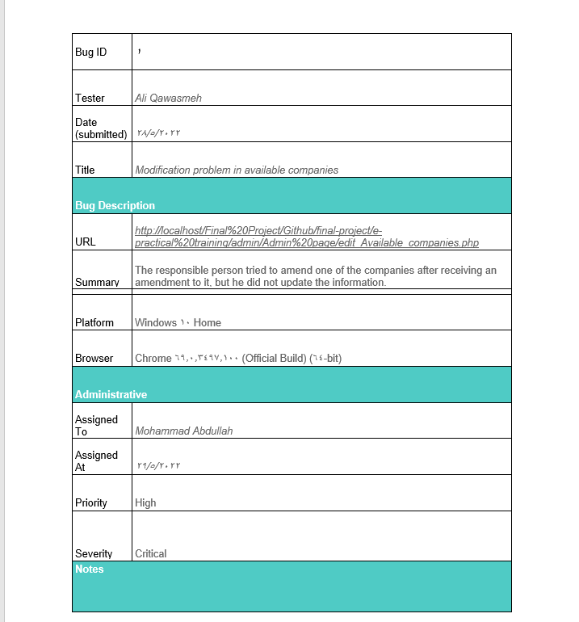

*Figure 8: Bug report.*

5.2.3 System Testing.

All intended functions work as expected to be after we tested them in the unit testing phase.

5.3 System results.

This project works as expected, as the student can choose the company he wants or the type of training and sends the admission file through the website to the university.

Also, companies provide training offers to the university and contract with it to train students, and they also evaluate students monthly and present it to the university.

5.4 Discussion and evaluation.

Below is the result of the survey that was sent to a sample of users to try out the practical e-training GUI:

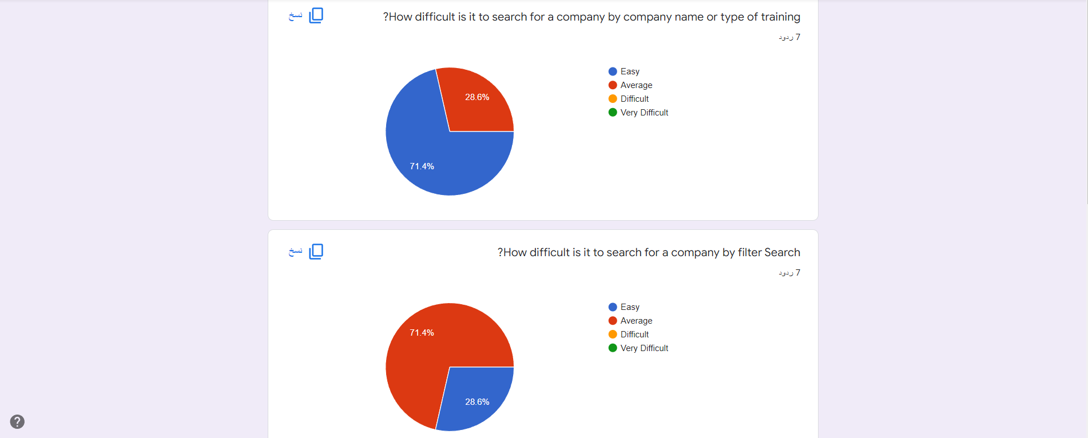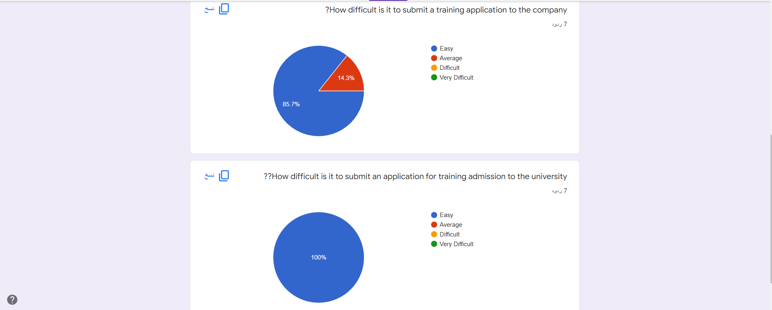

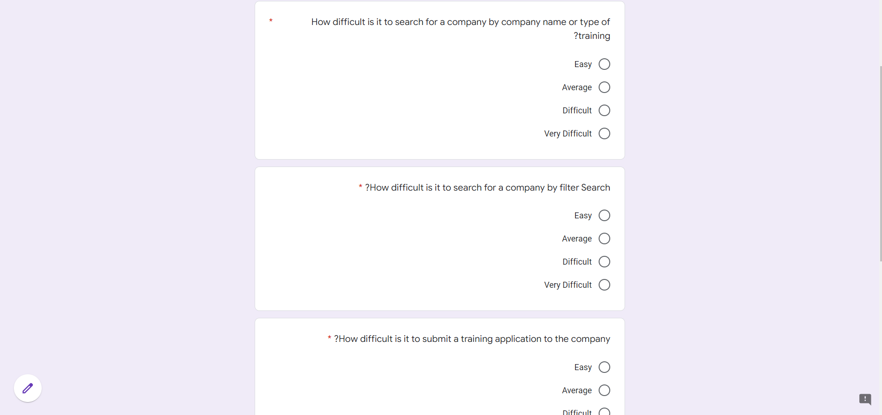

<https://docs.google.com/forms/d/e/1FAIpQLSdqn9qQQi-Sp3iCSw6_mZn6KZ-wWIWO7Mo9TiIQKAhddPm5OQ/viewform>

**Chapter 6**

**“Conclusion”**

6.1 Overview

The site works as intended, where the student can choose the company, he wants and the type of training he wants, submit an application to the company and then send the admission file to the admin site.

6.2 Summary

The electronic practical training system will greatly benefit students and the university and make it easier for them to apply to companies. The system also allows technology companies to apply to the university in an easy and fast way. The system was developed using agile methodology with Kanban board as it allows to divide the project into parts and follow each part. PHP and HTML CSS JAVASCRIPT were used as development languages ​​for the project. As for the database, MySQL was used to develop the database. After implementing the system with all its functions, we validated the system using two techniques, the first method was unit testing and the second was system integration testing as described in chapter 5, and by the end of the system testing it shows that it was easy to use and very useful.

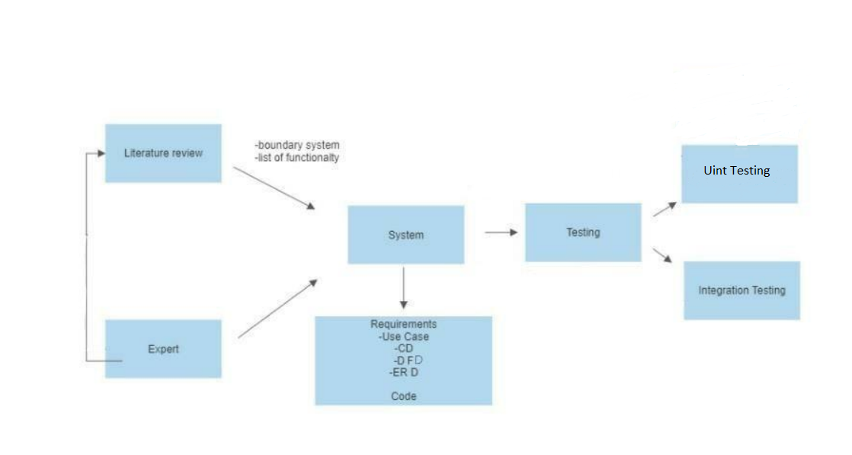

6.3 Achieved Objectives

❖ **"To understand the current situation of the project scope and problem statement."**

A study was conducted and it was found that there is no website for submitting training requests to companies. The problem has been made and understood and presented in Chapter 1.2.

**❖ "** **To develop the World Islamic Sciences Education University Electronic Services"**

The idea came to build a system that helps the university develop electronic services and raise their level. An easy-to-use and understandable system were created and presented and explained in Chapter 3.3.1 Functional Requirements.

**❖ “System validation to make the application process more efficient.”**

This goal is considered one of the most important goals. The system was presented and used by a group of students and then their views were presented on the graphs in the fifth chapter (5.4 discussions and evaluation). This made the system and booking process more efficient.

6.4 Limitation

We faced many challenges during creating this project as follows:

• There were no similar systems to ours in other universities which made it difficult for us to do a comparison of the new services that our system provides

• The number of samples that tested the system was limited due to the lack of time for students

6.5 Future Work

* Mobile App
* A notification bar and a message sent to the admin to remind him if there is a new request on the system Distance learning system

References:

[1] <https://www.forbes.com/sites/jonyounger/2019/09/14/surgeons-are-joining-the-freelance-revolution-meet-nash/?sh=1837801533e6>

[2] <https://www.youtube.com/c/thecharmefis>

[3] <https://www.goskills.com/Project-Management/Resources/When-to-use-agile-project-management>

[4] [https://iwconnect.com/agile-methodologies-scrum-vs-kanban-advantages-disadvantages/?fbclid=IwAR3cbVeN-573aPIqjCazWAxnsktdiaFu8tf4j8c6VcHkFIVb93Mv6T5A2mQ#:~:text=%20Some%20major%20advantages%20are%20listed%20here%3A%20,process%207%20Increased%20productivity%20and%20efficiency%20More%20](https://iwconnect.com/agile-methodologies-scrum-vs-kanban-advantages-disadvantages/?fbclid=IwAR3cbVeN-573aPIqjCazWAxnsktdiaFu8tf4j8c6VcHkFIVb93Mv6T5A2mQ%23:~:text=%20Some%20major%20advantages%20are%20listed%20here%3A%20,process%207%20Increased%20productivity%20and%20efficiency%20More%20)

[5] <https://www.w3schools.com/>

[6] <https://stackoverflow.com/>

Appendix:

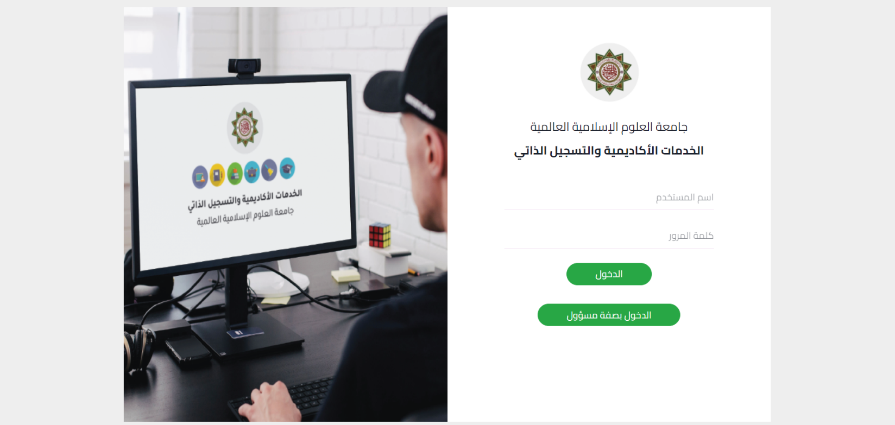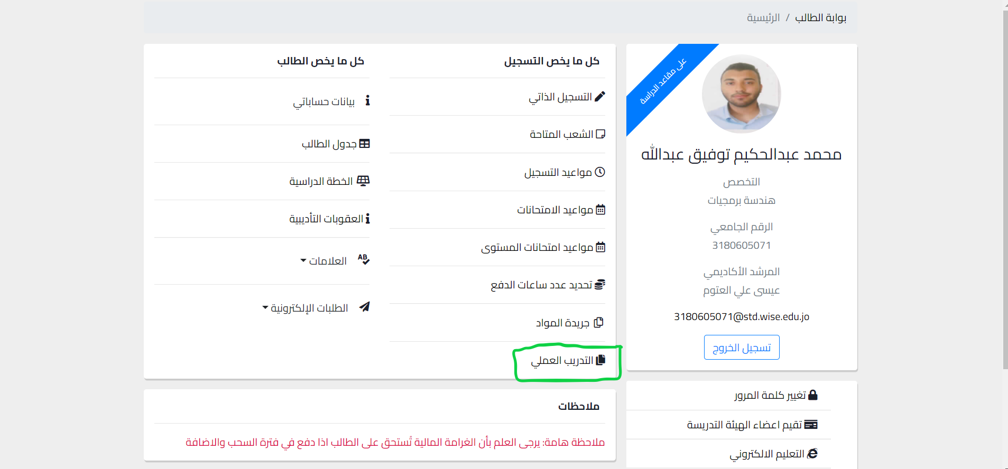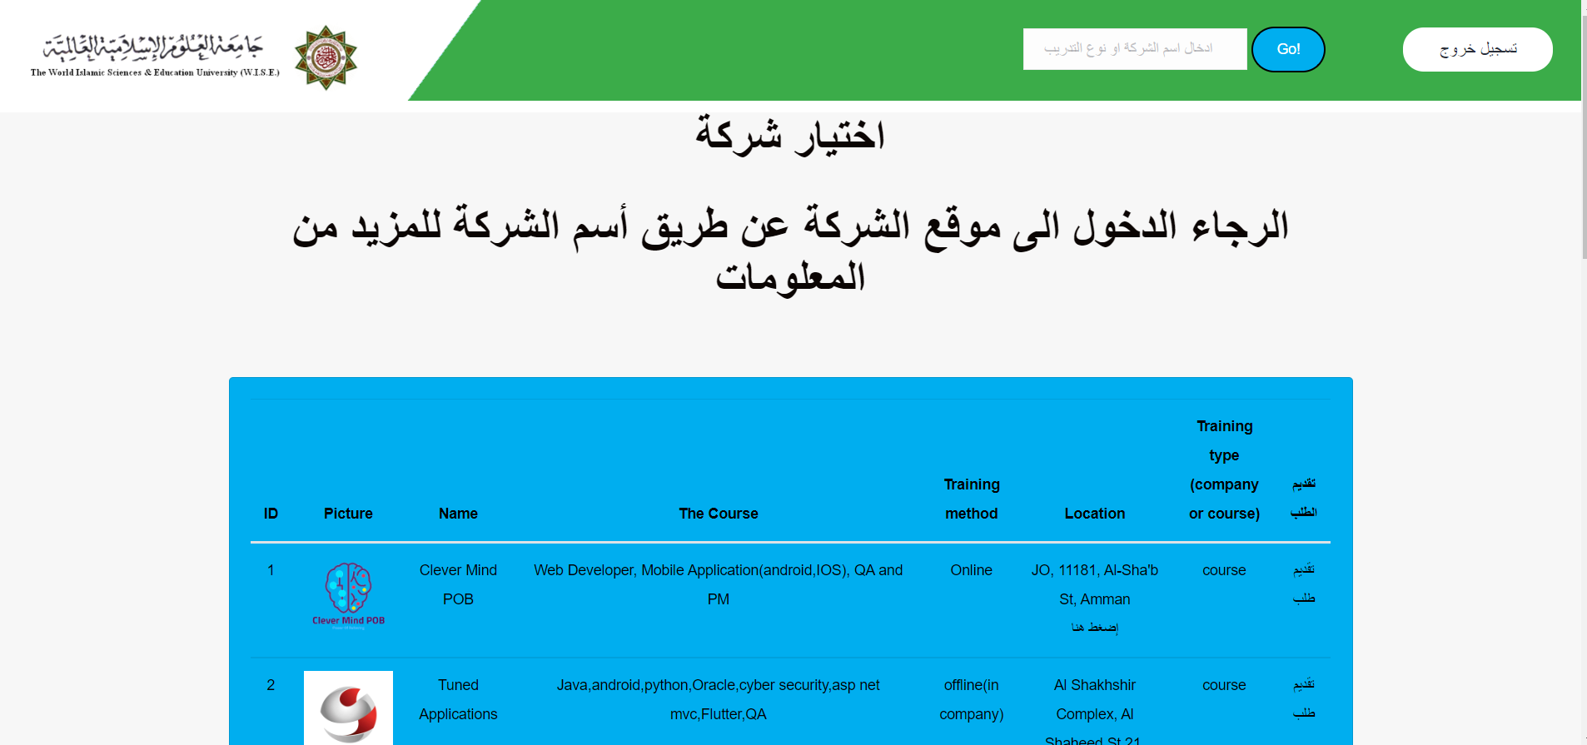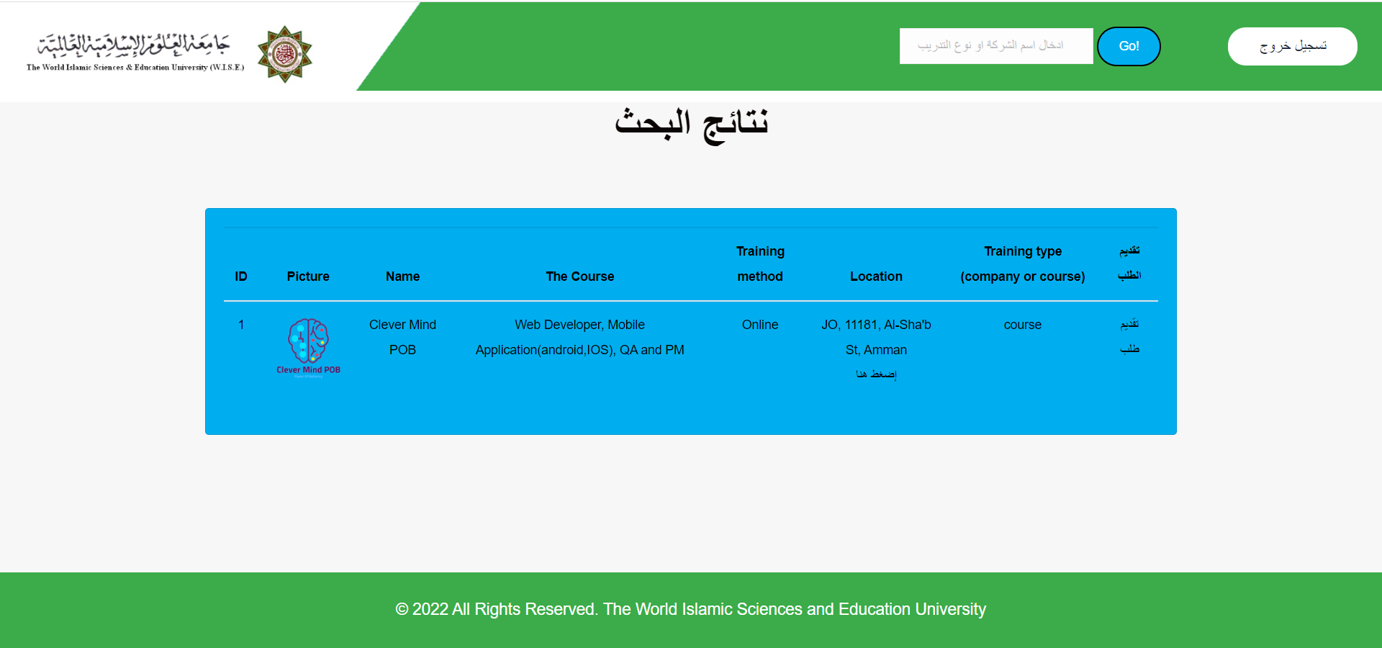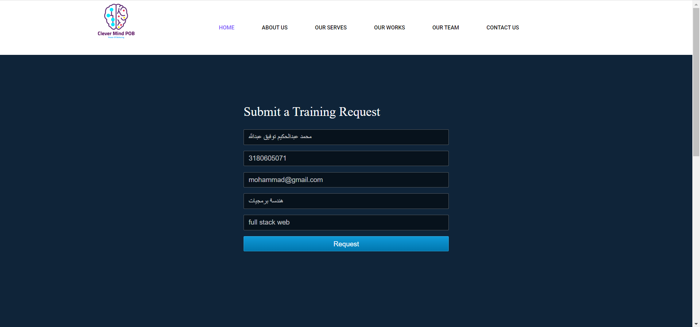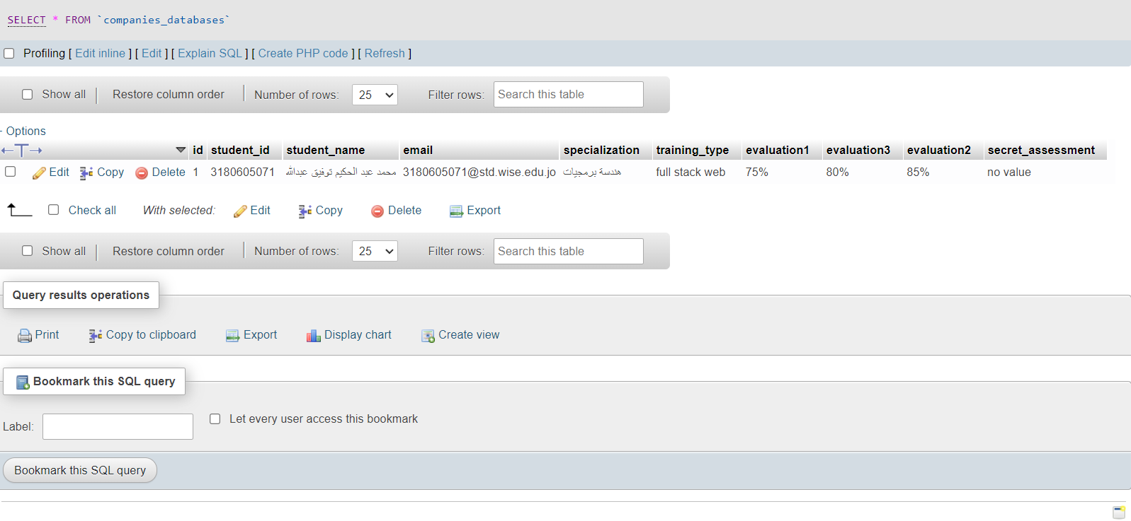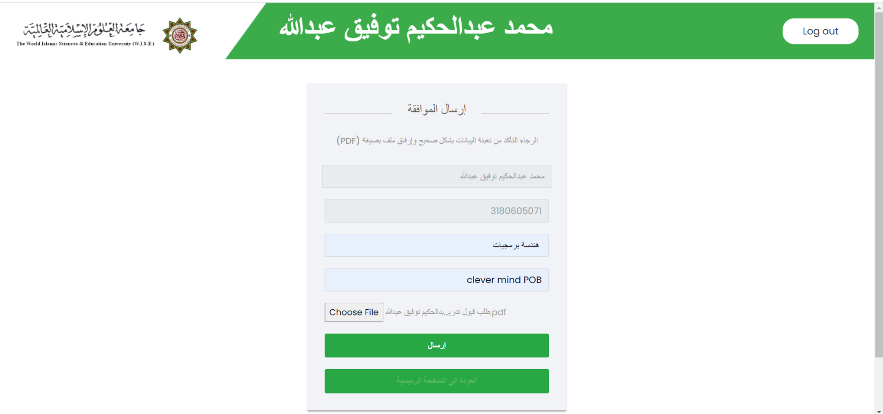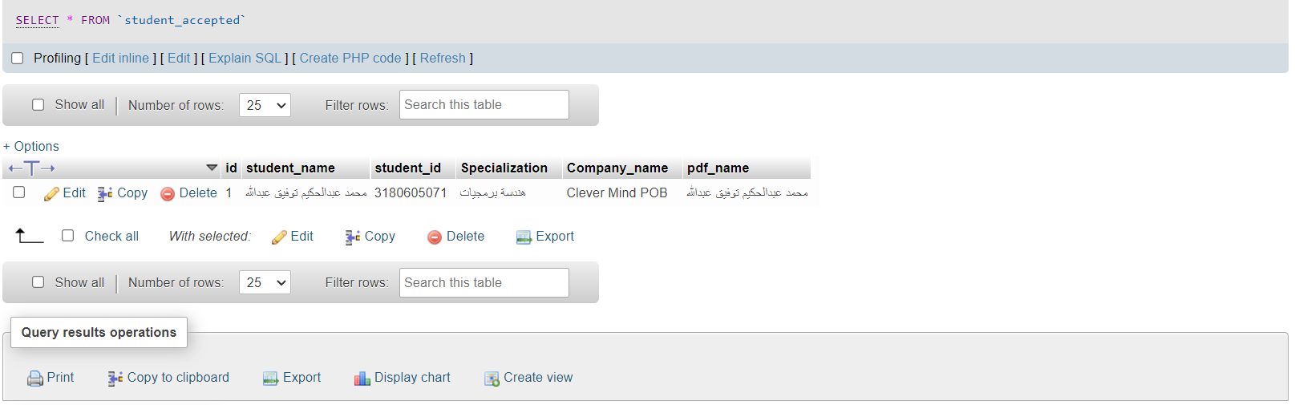

**\* On the home page there is a file of instructions where there is a full explanation of how the site works.**